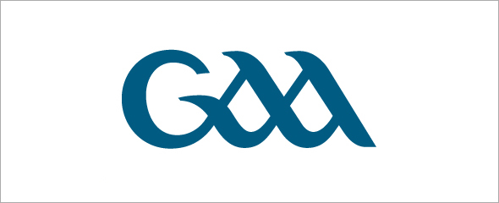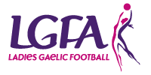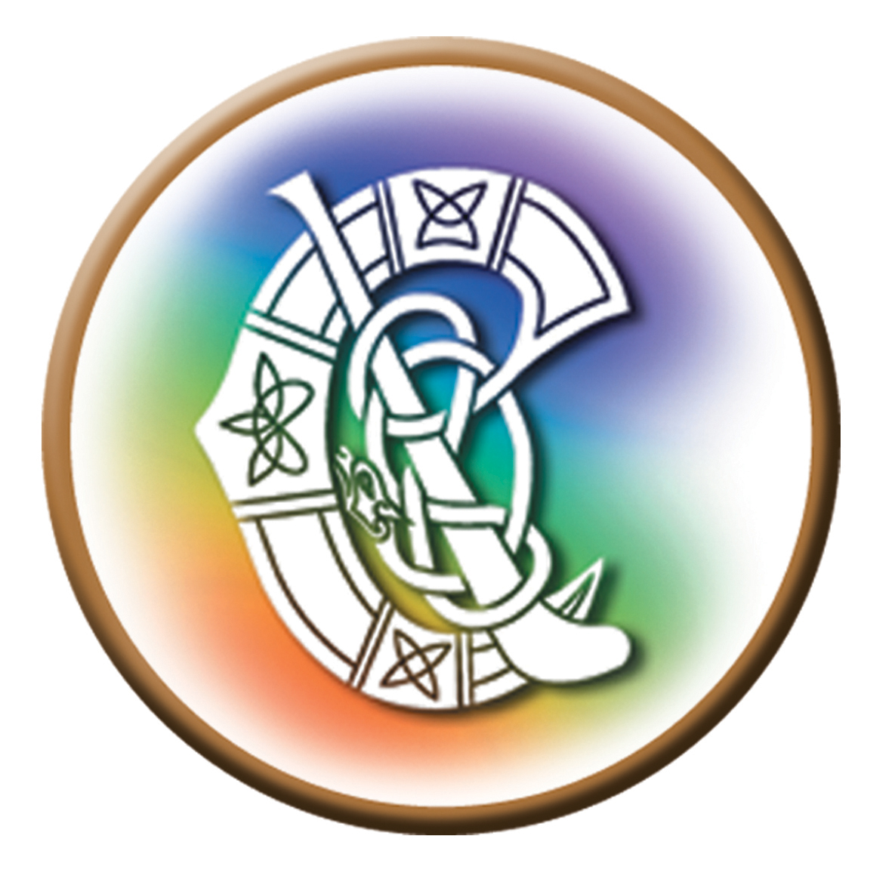

Main Recommendations of the One Club Committee

Ní neart go cur le chéile
Terms of Reference

The committee was provided with the following terms of reference:

1: Examine in detail single club affiliation for GAA, Ladies Football, Camogie, Handball, Scór, Rounders.

2: Examine single membership fee incorporating family membership

3: Examine Players Injury Scheme for all players.

4: Examine single Club Colours.

5: Single Club Executive – recommend make up of representation from each code.

6: Outline Advantages/Disadvantages of single club unit.

7: Make recommendations on proposed club structure that is best for all organisations and discuss the implications, if any.

All of the above points are discussed in this report, under various headings.

The One Club Committee

The Committee comprised of the following people:

- Seán Breathnach, Cathaoirleach

- Éamonn Foiréis

- Ciarán Ó Lochlainn

- Ciarán Ó Lidí

- Eibhlín Ní Ruairc

- Pádraig Ó Rinn,

- Martina Ní Dhiolún

- Órla Nic Consaidín

- Gearóidín Biadhtach Uí Uaine

- Colm Ó hÓbáin

- Sinéad Ní Chonchúir
Executive Summary

The first action by the One Club Committee was to create a definition of what is meant by the term ‘integrated club’. The committee felt that the term ‘One-Club’ best represented the movement of units to come together and this term is used throughout this report as opposed to the term ‘integrated club’. The first line of the definition of the ‘One-Club’ is that “the one-club is one that equally promotes the games, ideals and aspirations of the Ladies Football Association, Camogie Association and the GAA.” The committee then moved to address all of the topics in the terms of reference, with a constant reference to this definition.

A number of key decisions have been taken by the committee, with the main ones being summarised as follows:

1: Intregration will be on an optional basis and will not be compulsory. However, it will be encouraged and supported by all three Associations.

2: The three Associations will remain as separate governing bodies, retaining their unique identities.

3: The three Associations will merge the rules on Club administration. Therefore, all three Associations will have their own club constitution that is based on the current GAA Club Consitution. Therefore, whether any unit of the three Associations is a stand alone unit or operates in a one club scenario, the rules governing general administration etc will be the same.

4: The three Associations will adopt the same rules on membership in order to achieve standardisation across the Associations. In the ‘One-Club’, all members of this unit will become members of all three Associations.

5: There will be one Executive Committee, one club bank account and one fundraising mechanism in the club.

These decisions will facilitate the coming together of club units in to a ‘One-Club’ secnario. The club will be recognised as a unit of the three Associations and will affilaite to all three. An Executive Committee will be elected to manage the business and affairs of the club and the officers of this committee will be officers of the three Associations. The Club Constition will reflect that the unit is affiliated to the three Associations and will set out the rules regarding general club administration, the holding of the club AGM and so on.
All fundraising will take place as one, with standardised membership fees being set across the club.
1: Definition of an integrated club

1.1 Definition:

The first act of the committee was to develop a definition of the ‘One-Club’, outlined as follows:

The one-club is one that equally promotes the games, ideals and aspirations of the Ladies Football Association, Camogie Association and the Gaelic Athletic Association. Its administration is governed by a single constitution, which provides for the election of an Executive Committee to manage the business and affairs of the club as well as providing for a single membership structure. All activity, including fundraising and games development are carried out to support the development of the club and the promotion of all games.

This definition was the basis of the committees work.
2: Examine in detail a single club affiliation for GAA, Ladies Football and Camogie

2.3 Committee Recommendations:

1: In the integrated club, separate club affiliations on or before the specified dates will still need to be submitted to the individual Associations. However, the affiliation will take place under one name e.g. X G.A.A. Club, ‘X GAA, Ladies Football and Camogie Club’ etc.

This is in order to facilitate the unit’s participation in competitions run by the respective Associations, participation at County Conventions etc. and to facilitate players of the various codes being subject to the disciplinary procedures of the respective Association.

Therefore, while the club will have one name and be governed by one constitution (this is discussed later), the club will affiliate to the three Associations, assuming the club is catering for the codes of the three Associations.

2: The committee recommends that the club moves to one set of colours. However, should a particular code in the club wish to retain its colours for historical and traditional purposes, that can be facilitated.
3: Categories of Membership in the three Associations, dates of registration and the Membership year

3.6 Committee recommendations:

1: All three Associations adopt the same categories of membership at club level. These categories will be Full, Youth, Honorary and Social membership. This will require a rule change for the Camogie Association and the Ladies Football Association.

At Association level, all three Associations will adopt the categories of Full and Youth Membership. The Ladies Football Association can continue with the category of Associate membership as this cannot be granted by a club, and therefore will not affect the ‘One-Club’.

The purpose of this change is to standardise membership across the Association in order to facilitate the integrated clubs.

2: The Honorary category of membership in Ladies Football will be redefined to confer voting rights, in order to be consistent with the GAA category of Honorary membership.
3: Ladies Football and Camogie will increase the age of voting from 16 to 18.

The purpose of this change is to facilitate voting at integrated club AGM’s. It would be difficult to administer a situation where certain members could vote at 16 years of age and others would need to be 18. The change is in line with the national age of voting, which is 18.

4: In the ‘one-club’, all members (except Social members) will become either Full or Youth members, depending on their age, of the Gaelic Athletic Association, the Ladies Football Association and the Camogie Association.

All will be members of the one club, based on the categories as outlined above.

Players will be registered with their respective Associations and in accordance with the dates specified etc. as outlined by the three Associations. Therefore, GAA and Camogie players will still need to be registered three days before a game, current Ladies Football players before June 1st and so on.

5: All three Associations will move to use the GAA online registration system, as currently operated by Servasport. The system will be specifically adapted to facilitate registration of Ladies Football and Camogie players and members.

6: In relation to membership year and the date of registration for voting purposes, the committee recommends the final date for registration in order to entitle a person to voting rights across the three Associations be changed to June 1st.

7: In relation to players who play one of the codes with an integrated club, but still wish to maintain an Association with a club in their home parish/catchment area, the committee recommends that the players become Full/Youth members of the integrated club. However, should they wish to retain an association with the club in their home parish/area, they can become Social Members of that club.

Certain anomalies arise. For example, in the case of a player that is playing Camogie with one integrated (One-Club) unit and Ladies Football with another integrated (One Club) unit, the committee is of the view that this player will need to become a Full/Youth member of both clubs in order to meet the playing rules of both Associations. These anomalies are unavoidable.

4: Membership fees, injury fund fees and family membership

4.6 Committee Recommendations

1: Rule 6.1 in the G.A.A. Club Constitution already provides clubs with the flexibility to introduce their own categories of membership fees. This can include a family membership fee, incorporating those in the family who are involved in the various organisations. Therefore, there is no requirement to introduce a category of family membership fee. A family will consist of Full and Youth members, as defined in rule 2.1 (a) of the GAA Official Guide and the family membership fee will be as decided by the club.

2: There should be one set of fees in the ‘One-Club’, covering all categories of Full, Youth and Social membership. The ‘One-Club’ should not apply different fees to players based on the code they are playing.

3: Ladies Football will amend rule 64 to state that in a unit that is operating in a ‘One Club’, the Full Member fee for non-players will only apply to the 5 particular officers of the Club Executive Committee (Chairman, Secretary, Treasurer, Registrar and Children’s Officer) and mentors of Ladies Football teams.

4: The GAA will review its funding arrangements with Ladies Football and Camogie relating to any increase in funds received from the €2 Association membership fee arising from an increase in membership due to the ‘One Club’ process.

5: Examine Players Injury Fund for all players

5.1 Committee Recommendations

The committee has agreed, in principal, the three Associations should move to one insurance and injury fund scheme. However, this would be dependent on their being a cost/administration benefit for all three Associations.

A comparison between the three schemes in terms of costs and benefits etc. is being carried out at present. It is accepted that this is a major undertaking and will not be completed by the end of the committee’s work.
6: Club Constitution, Dates of Club AGM, and the Club Executive

6.7 Committee Recommendations:

1: The Camogie Association and the Ladies Football Association will adopt the GAA Club Constitution as the Camogie Association Club Constitution and Ladies Football Association Club Constitution. This will involve removing rules relating to club administration from their Official Guides and inserting the Club Constitution as one document.

This will help ensure uniformity across the three Associations in relation to club administration, whether clubs operate as the ‘One-Club’ clubs or as stand-alone units.

2: The ‘One-Club’ club will operate from Club Constitution. Amendments can be forwarded to the GAA County Committee in accordance with rule 14.1 of the Club Constitution. Property currently vested in the GAA will continue to be held in trust by the GAA. Any changes to the constitution at national level will need to be discussed by the three Associations.

3: Each club will have an Executive Committee, elected in accordance with rule 7.1 of the Club Constitution. Therefore, each officer will be acting on behalf of the three Associations i.e. the Club Children’s Officer will be the Children’s Officer for the three Associations and so on.

4: Each club will, at a minimum have 5 sub-committees, namely:

- Ladies Football
- Camogie
- Hurling and Football
- Finance and Fundraising
- Fixtures

The chairperson of each sub-committee in the club will sit on the club Executive. Other sub-committees can be appointed as required by the club. A club can also have a separate hurling and separate football sub-committee, if this is required. The Fixtures Sub-Committee will deal with the use of the club grounds by the various teams in the club.

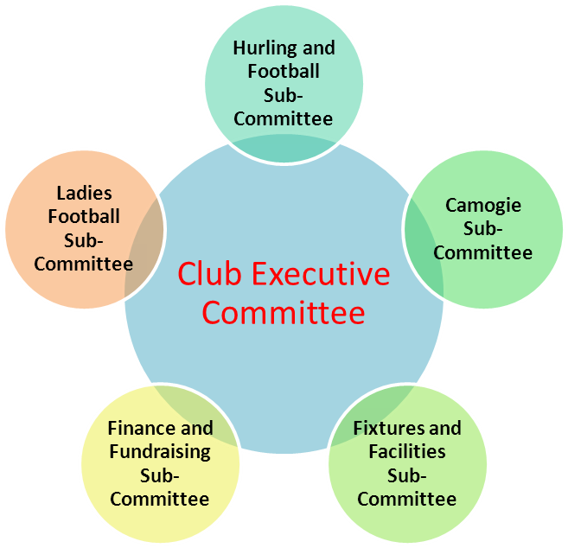

Fig 1: Committee structure in the One-Club, with a minimum of 5 sub-committees

6: The GAA will include Coaching Officer as a listed officer on its Executive Committee. In the ‘One-Club’, this officer will be known as Development/Coaching Officer’.

7: Rule 7.2 of the Club Constitution in the integrated club will be amended to read:

The Executive Committee shall be comprised of the Chairperson, Vice-Chairperson, Treasurer, Secretary, Registrar, Officer for Irish Language and Culture, Children’s Officer, Public Relations Officer, Coaching/Development Officer, Chairperson of the Ladies Football Sub-Committee and one Ladies Football Player representative, Chairperson of the Camogie Sub-Committee and one Camogie Player representative, Chairperson of the Hurling and Football Committee and one GAA Player representative, Chairperson of the Finance and Fundraising Sub-Committee and Chairperson of the Fixtures Sub-Committee and other officers as required.
:
This is a committee of 17 people. Other officers can be added as required. For example, if the club adds another sub-committee, then the chairperson of this sub-committee can be added to this Executive. The club may wish to appoint one of the named officers above as a delegate to one of the County Committees or may wish to elect the required delegates specifically.

8: The Club will have one Bank Account. The Club Treasurer will have responsibility for all financial matters in the club.

9: Fundraising for the club will be handled by the Finance and Fundraising Committee. All fundraising will be for the club and not for individual sections.

7: Advantages and Challenges of the one club model

7.1 Advantages

The committee concluded that there are number of advantages in pursuing the ‘One-Club’ model approach. These are outlined as follows:

1. Cohesive promotion of Gaelic games and activities nationally across clubs, communities and schools.

2. Gaelic Games family units building capacity and resources at community level.

3. Organisations being durably embedded in the local community.

4. Economies of scale and harmonisation of objectives for the benefit of each Club and the respective Associations.

5. Social Capital promoting integrated collaboration at community level while bonding similarly motivated people with norms and reciprocity.

6. Promoting Parity of Esteem amongst Club members and the respective Associations.

7. Mutual Recognition for members / players / referees / coaches / awards/ accreditations.

8. Lends critical mass and scale and potential benefits to future commercial opportunities such as affinity programmes at club, county, national and international levels.

7.2 Challenges

Undoubtedly, there are challenges too in pursuing the ‘One-Club’ model. The committee is of the view that these challenges can be met through openness with the membership of the clubs and with a full discussion of the process. The committee noted that the following challenges will exist.

1: They may be a strong tradition of the clubs as individual units in an area. This may make members feel that they are ‘letting something go’. However, pursuing the ‘One-Club’ model is about building for the future, based on the past.

2: Individual personalities will play a part from time to time. These personality issues can arise in a single unit every bit as much as they will arise in the ‘One-Club’ unit. However, these issues can be worked through and the experience of the Committee is that any ‘One-Club’ unit that was spoken to championed the benefits of the move as opposed to any challenges that may have arisen.

8: Discipline in the Club

8.1 Committee Recommendations

1: Discipline of players, mentors etc during games: These matters will be handled by the
Association in charge of the fixture and any appeal with go through the appeals process of
that Association. If a Ladies Football player is suspended from playing, the suspension will
not extend to Camogie and vice-versa.

2: Child protection matters: These will be dealt with by the structures that currently exist. A sanction is applicable to all 3 Associations and procedures have been standardised.

3: Internal disciplinary issues: As all members will be members of the GAA, these matters will be dealt with by the GAA disciplinary procedures, as outlined in rule 5.11.1 to 5.11.3). However, penalties will extend to the three Associations. This means that if person is suspended from the One Club, they will be suspended from the club and the three Associations and therefore cannot become involved in a stand-alone GAA club, Camogie or Ladies Football club. The appeal process will be through the current GAA appeals process.

4: Players, Officers and all Members will be bound by the Code of Conduct of all three
Associations. This includes the ‘Code of Practice for All Officers of the Camogie Association’.

